Pollution Incident Response Management Plan

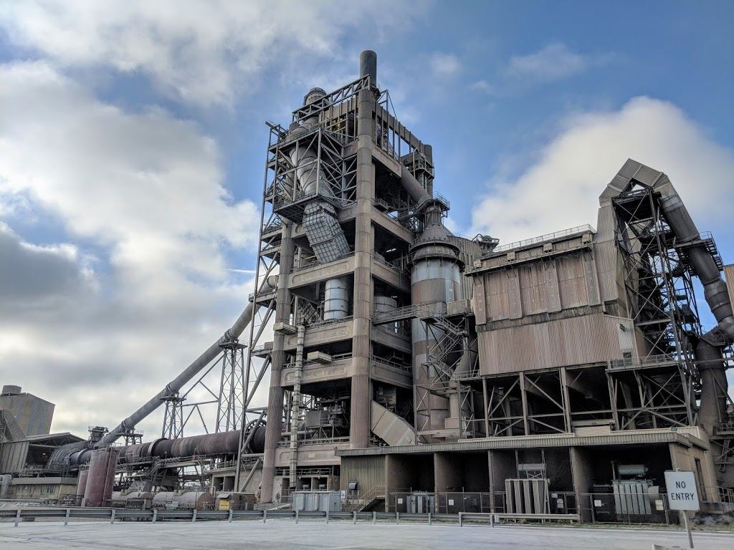

Berrima Cement Works
Taylor Avenue, New Berrima NSW 2577
Version 10: 1 April 2022

Document Control Sheet
Current Rev. | Date Implemented | PIRMP Test Schedule | Date for Next Review
10 | 28/04/2022 | 12 months (19 April 2022) | April 2023

Rev. | Date | Prepared by | Approved By | Revision Details
01 | December 2012 | Karin Schianetz | Stuart Hutchings | Document Created
02 | 24 January 2013 | Karin Schianetz | Stuart Hutchings | Included reference to Map 60059
2.1 | September 2013 | Alex Wnorowski | Stuart Hutchings | Changes reflecting new company structure
03 | September 2014 | Alex Wnorowski | Stuart Hutchings | Annual Review
04 | September 2015 | Alex Wnorowski | Stuart Hutchings | Annual Review
05 | March 2017 | Micheal Curley | Stuart Hutchings | Major Review
06 | March 2018 | Ibrahim Mulhern | Stuart Hutchings | Annual review
07 | March 2019 | Beinda Prideaux | Stuart Hutchings | Updated Staff contact details
08 | April 2020 | Belinda Prideaux | Dean Beltrame | Over haul document to meet new EPA PIRMP guidelines
09 | April 2021 | Greg Johnson | Dean Beltrame | Annual review, update staff, include gas risk
10 | April 2022 | Ben Williams | Dean Beltrame | Update to new EPA PIRMP guidelines  Update formatting  Update staff contacts  Update maps

Contents
PART A: Legislative Requirements
1. Document Purpose and Scope 5
2. Legislative Requirements 5
3. Definition of a ‘Pollution Incident’ 8
4. Site Location and Layout 8
5. Potential Polluting Substances 11
6. Staff Roles and Responsibilities 18
7. Internal Pollution Incident Reporting 19
8. External Pollution Incident Reporting 20
8.1. Pollution Incident Authority Contact List 20
8.2. Community Notification Contact List 21
9. Incident Response Training 23
10. PIRMP Testing 23
11. PIRMP Review 24
11.1. Event Based 24
11.2. Time Based 24
12. Risk Assessment of Potential Incidents 24
PART B: Incident Response Actions and Notification Logs
13. Incident 1: Diesel or Hydrocarbon Spill 28
14. Incident 2: Excessive Airborne Dust 31
15. Incident 3: Dam Failure 33
16. Incident 4: Electrostatic Precipitator Trip 35
17. Incident 5: Gas Leak 37
18. Incident 6: Loss of Radioactive Material 39
19. Pollution Incident Notification Log 41
20. Immediate Notification Sheet 44

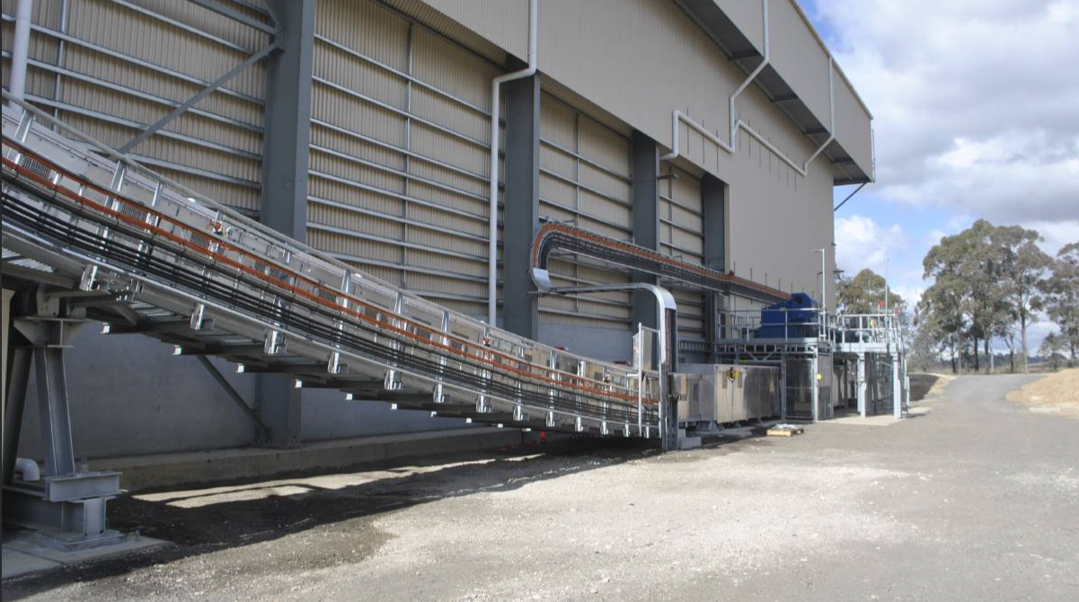

PART A:
Legislative Requirements

Document Purpose and Scope
The purpose of the Berrima Cement Works (BCW) Pollution Incident Response Plan is to:
- Provide direction to the staff in responding to pollution incidents at the BCW operations;
- Ensure timely communication about a pollution incident is provided to staff at the premises, the Environment Protection Authority (EPA), other relevant authorities specified in the Protection of the Environment Legislation Amendment Act (POELA Act) (including Wingecarribee City Council, NSW Ministry of Health, Safework NSW, and Fire and Rescue NSW) and persons outside the operations who may be affected by the impacts of a pollution incident that is not trivial;
- Minimise and control the risk of a pollution incident at Dunmore Quarry by identifying key risks and planned actions to minimise and manage those risks;
- Detail the training requirements for this plan, identifying persons responsible for implementing it, and ensuring that the plan is regularly tested for accuracy, currency and suitability.
- This PIRMP must be followed by employees, contractors and visitors of BCW, to assist in the early response to, and reporting of, a pollution incident. A hard copy of the current PIRMP is kept at BCW and is made publically available on the Boral environmental reporting website:
https://www.boral.com.au/what-we-do/environmental-reporting
Hard copies of the PIRMP are located at the following locations onsite:
- Reception
- Control Room
- ATW Office
- Group Engineering/Procurement
- Boral Concrete – Deisel Loco Shop
- First Aid Room
This document accompanies the Berrima Emergency Response Plan CEM-BER-OHS-1 which details immediate response actions such as evacuation and first aid procedures in a range of emergency scenarios.

Legislative Requirements
The specific requirements for a Pollution Incident Response Management Plan (PIRMP) are set out in Part 5.7A of the POEO Act and the Protection of the Environment Operations (General) Regulation 2009 (POEO(G) Regulation).
Part 3A of the POEO Act and the Protection of the Environment Operations (General) Regulation 2009 (POEO(G) Regulation) describes specific components and requirements of a PIRMP. Table 1 provides the reference to these requirements and the location these are addressed in the document.

Table 1 Summary of Legislative Requirements
Section/Clause | Requirement | Location in PIRMP
Part 5.7A POEO Act 1997
147 | (1) For the purposes of this Part—  (a) harm to the environment is material if—  (i) it involves actual or potential harm to the health or safety of human beings or to ecosystems that is not trivial, or  (ii) it results in actual or potential loss or property damage of an amount, or amounts in aggregate, exceeding $10,000 (or such other amount as is prescribed by the regulations), and  (b) loss includes the reasonable costs and expenses that would be incurred in taking all reasonable and practicable measures to prevent, mitigate or make good harm to the environment.  (2) For the purposes of this Part, it does not matter that harm to the environment is caused only in the premises where the pollution incident occurs. | Section 3
153A | The holder of an environment protection licence must prepare a pollution incident response management plan that complies with this Part in relation to the activity to which the licence relates. | EPL 1698 and this document
153C | A pollution incident response management plan must be in the form required by the regulations and must include the following—  (a) the procedures to be followed by the holder of the relevant environment protection licence, or the occupier of the relevant premises, in notifying a pollution incident to—  (i) the owners or occupiers of premises in the vicinity of the premises to which the environment protection licence or the direction under section 153B relates, and  (ii) the local authority for the area in which the premises to which the environment protection licence or the direction under section 153B relates are located and any area affected, or potentially affected, by the pollution, and  (iii) any persons or authorities required to be notified by Part 5.7,  (b) a detailed description of the action to be taken, immediately after a pollution incident, by the holder of the relevant environment protection licence, or the occupier of the relevant premises, to reduce or control any pollution,  (c) the procedures to be followed for co-ordinating, with the authorities or persons that have been notified, any action taken in combating the pollution caused by the incident and, in particular, the persons through whom all communications are to be made,  (d) any other matter required by the regulations. | Section 7  Section 8  Section 8  Section 13 to 18  Section 13 to 20  Section 20
153D | A person who is required to prepare a pollution incident response management plan under this Part must ensure that it is kept at the premises to which the relevant environment protection licence relates, or where the relevant activity takes place, and is made available in accordance with the regulations. | Section 1
153E | A person who is required to prepare a pollution incident response management plan under this Part must ensure that it is tested in accordance with the regulations | Section 10
153F | If a pollution incident occurs in the course of an activity so that material harm to the environment (within the meaning of section 147) is caused or threatened, the person carrying on the activity must immediately implement any pollution incident response management plan in relation to the activity required by this Part | Section 7 and 8
Part 3A POEO(G) Regulation 2009 Pollution Incident Response Management Plans
note: See also 153C (a)-(c) of the POEO Act 1997
98C(1) (a) | A description of the hazards to human health or the environment associated with the activity to which the licence relates, | Section 5, Section 12
98C(1) (b) | The likelihood of any such hazards occurring, including details of any conditions or events that could, or would, increase that likelihood, | Section 12
98C(1) (c) | Details of the pre-emptive action to be taken to minimise or prevent any risk of harm to human health or the environment arising out of the relevant activity | Section 12
98C(1) (d) | An inventory of potential pollutants on the premises or used in carrying out the relevant activity | Section 5
98C(1) (f) | A description of the safety equipment or other devices that are used to minimise the risks to human health or the environment and to contain or control a pollution incident, | Section 5, Section 12-18
98C(1) (g) | the names, positions and 24-hour contact details of those key individuals who:  are responsible for activating the plan, and  are authorised to notify relevant authorities under section 148 of the Act, and  are responsible for managing the response to a pollution incident, | Section 6,7,20
98C(1) (h) | the contact details of each relevant authority referred to in section 148 of the Act, | Section 8,20
98C(1) (i) | Details of the mechanisms for providing early warnings and regular updates to the owners and occupiers of premises in the vicinity of the premises to which the licence relates or where the scheduled activity is carried on | Section 8.2, Section 12-20
98C(1) (j) | The arrangements for minimising the risk of harm to any persons who are on the premises or who are present where the scheduled activity is being carried on | Section 12-20
98C(1) (k) | A detailed map (or set of maps) showing the location of the premises to which the licence relates, the surrounding area that is likely to be affected by a pollution incident, the location of potential pollutants on the premises and the location of any stormwater drains on the premises | Section 12-20
98C(1) (l) | A detailed description of how any identified risk of harm to human health will be reduced, including (as a minimum) by means of early warnings, updates and the action to be taken during or immediately after a pollution incident to reduce that risk, | Section 12-20
98C(1) (m) | The nature and objectives of any staff training program in relation to the plan | Section 9
98C(1) (n) | The dates on which the plan has been tested and the name of the person who carried out the test, | Section 10
98C(1) (o) | The dates on which the plan is updated, | Document Control
98C(1) (p) | The manner in which the plan is to be tested and maintained. | Section 10,11

Definition of a ‘Pollution Incident’
The definition of a pollution incident is:
“pollution incident means an incident or set of circumstances during or as a consequence of which there is or is likely to be a leak, spill or other escape or deposit of a substance, as a result of which pollution has occurred, is occurring or is likely to occur. It includes an incident or set of circumstances in which a substance has been placed or disposed of on premises, but it does not include an incident or set of circumstances involving only the emission of any noise.”
A pollution incident is required to be notified if there is a risk of ‘material harm to the environment’, which is defined in section 147 of the POEO Act as:
a) harm to the environment is material if:
i) it involves actual or potential harm to the health or safety of human beings or to ecosystems that is not trivial, or
ii) it results in actual or potential loss or property damage of an amount, or amounts in aggregate, exceeding $10,000 (or such other amount as is prescribed by the regulations), and
b) loss includes the reasonable costs and expenses that would be incurred in taking all reasonable and practicable measures to prevent, mitigate or make good harm to the environment.
BCW is now required to report non-trivial pollution incidents immediately to the EPA, NSW Health, Fire and Rescue NSW, Safework NSW and the local council.

Site Location and Layout
As shown in Figure 1, the site is situated within the Wingecarribe LGA and is zoned Heavy Industrial (IN3). The land to the immediate east and south is zoned General Industrial (IN1)
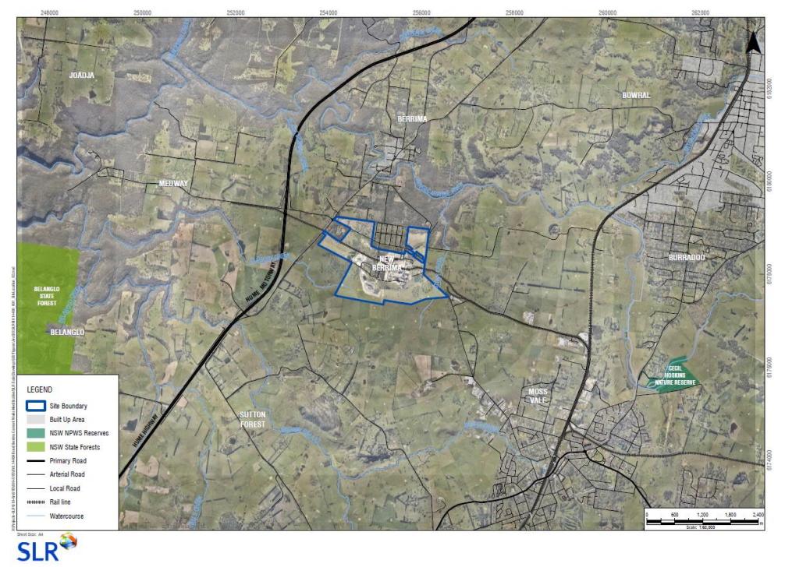
Figure 1 Site Location
The overall site layout of BCW is shown in Figure 2. Please note that Part B of this PIRMP contains detailed maps which describe the important details for each pollution incident scenario.
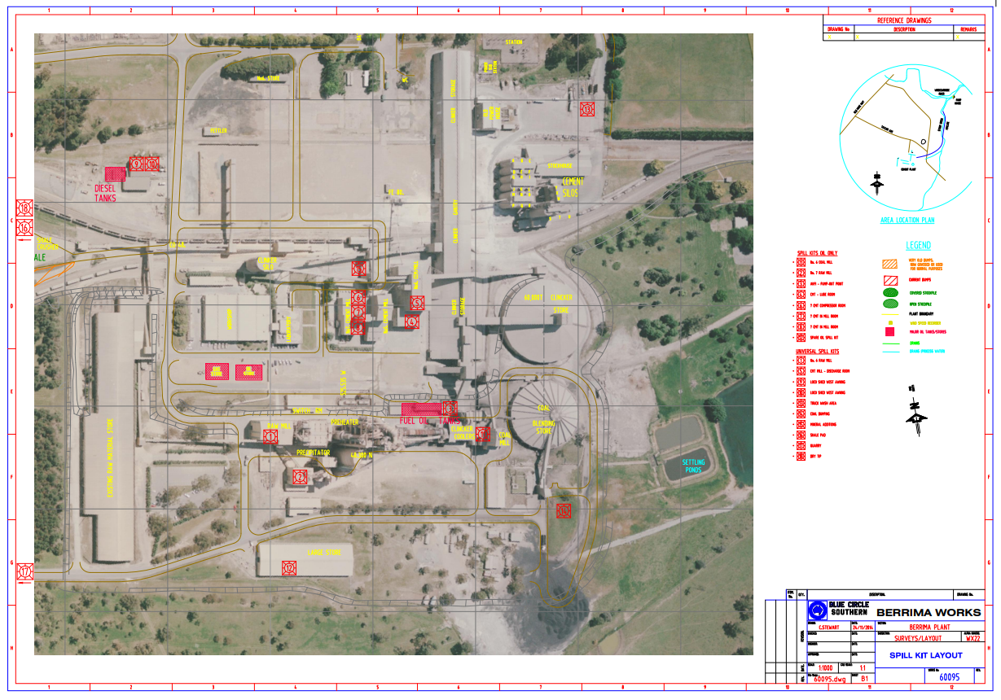
Figure 2 Site Layout

Potential Polluting Substances
Table 2 below is an inventory of potential pollutants kept on the premises. Figure 3 shows the map reference for the location of the storage. This inventory provides a description of the main hazards to human health or the environment, an assessment of the likelihood of the hazards occurring and also includes the current controls and safety equipment and/ or pre-emptive actions in place to minimise or prevent risk of harm to human health or the environment.
Table 3 details the typical volumes and location of hazardous material storage. Please note that these volumes are indicative in nature. The Hazardous and Dangerous Goods Register is located in the CCR outside the small conference room and will contain the most up to date information. Safety Data Sheets are stored via ChemAlert which is accessed via the Boral intranet under Applications.

Table 2 List of Polluting Substances: Initial Assessment
LIST OF POLLUTING SUBSTANCE STORAGES/USES AT SITE: INITIAL ASSESSMENT
(all Chemicals listed in this sheet are to be subjected to a risk assessment)
Site Name:  Berrima Cement |  |  |  |  |  | Responsible Person:  Operations Manger |  |  | Date:  08/04/2022
Name / description | Covered under Hazardous Chemicals/SDS? | Amount stored | Location of storage | Map reference. See Figure 3 | Likelihood of impact on neighbours |  | Current controls | See Risk Ass & PIRMP Response Action (see Below)
CHEMICALS/FUELS/LUBRICANTS (raw materials and products which can cause pollution)
Diesel | Class 3 | Variable: typical volumes listed in Table 3 | Diesel Storage Area | Ref A | LOW  Only if substances enter waterways and is transported off-site |  | Bunding  PMP  Training  Spill Kits  SOP  Inductions  Fire Fighting Equipment  Security | Incident #1
LPG | Flammable Gas  Class 2 | Variable: typical volumes listed in Table 3 | Depot 2 | Ref B | LOW  Only if flammable gas is spread off-site during high winds  Early warning required¹ |  | Bunding  PMP  Training  Spill Kits  SOP  Inductions  Fire Fighting Equipment  Security | Incident #5
Grinding aid | Class 3 | 10 000ltrs | Cement Mil 6  Cement Mill 7 | Ref C | LOW  Only if substances enter waterways and is transported off-site |  | Bunding  PMP  Training  Spill Kits  SOP  Inductions  Fire Fighting Equipment  Security | Incident #1
Oils/Solvents | Class 3 | Packaged goods up to 600ltrs | Oil Store /Loco Shed | Ref D | LOW  Only if substances enter waterways and is transported off-site |  | Bunding  PMP  Training  Flammable Cabinet  Spill Kits  Inductions  Fire Fighting Equipment  Security | Incident #1
Lubricants, Gases | Class 2 | Variable: typical volumes listed in Table 3 | Maintenance Workshop | Ref B | LOW  Only if substances enter waterways and is transported off-site |  | Fire Extinguishers  Concrete Floor  Enclosed Shed  Containment Cages and Cabinets | Incident #1 and Incident #5
Oils/Fuel | Class 3 | Variable:  typical volumes listed in Table 3 | Plant and Equipment (Workshop area) | Ref B | LOW  Only if substances enter waterways and is transported off-site |  | PMP  Training  Spill Kits  SOP  Inductions  Fire Fighting Equipment  Security | Incident #1
Acids |  | 2000ltrs | Powerhouse Ponds  Hotwells |  | LOW  Only if substances enter waterways and is transported off-site |  |  | Incident #1
Laboratory Chemicals |  | Variable <500Ltrs | Laboratory | Ref E | LOW  Only if substances enter waterways and is transported off-site |  | Fire Extinguishers  Concrete Floor  Enclosed Shed  Containment Cages and Cabinets  Security | Incident #1  Risk Assessment  Response Actions
Radioactive Material  Cs-137  Cf-252 | Class 7 |  | No. 6 Cement Mill  SC109  SC110  SC111  CO62 | Ref H | LOW  Only if substances escapes during maintenance or transport |  | Regular wipe tests and inspections by licenced contractor  Regular maintenance with licenced contractor  Transport via licenced contractor  Storage off site via licenced radiation store  Signage and restriction of access within close vicinity  Training  Security | Incident #6  Risk Assessment  Response Actions
MATERIALS (eg stockpiles, silos, bulk solids etc)
Product Stockpiles | N/A | Up to 50,000T | Dedicated on site | Ref F | LOW  Only if excessive sediment enters waterways and is transported off-site during significant rain events |  | Water sprays  Water Cart  Maintain manageable levels  Security | Incident #2  Risk Assessment  Response Actions
AQUEOUS (eg dams, wastewater tanks, other water storage area)
Water Storage Dam (Sediment) | N/A | 15ML Lake Breed  19ML Lake Quality | Lake Breed  Lake Quality | Ref G | LOW  Only if excessive sediment enters waterways and is transported off-site during significant rain events |  | Continue to use for dust suppression  Ensure pumps are maintained through scheduled maintenance  Routine site cleaning  Utilization of settling ponds and weirs  Discharge monitoring | Incident #3  Risk Assessment  Response Actions
Storm Water Drains | N/A | Variable | Site | Ref G | LOW  Only if excessive sediment enters waterways and is transported off-site during significant rain events |  | Straw Bales  Rubber and Earthen Berms  Audits and Inspections | Incident #3  Risk Assessment  Response Actions
SUBSTANCES IN PROCESSES (substances which could be emitted from operational process i.e. treatment plants, vehicles etc)
Mobile Plant (onsite) BORAL | Class 3 | Up to 15 on site | Dedicated on site | Operational traffic areas | N/A |  | Spill Kits  Pre start checks  PMP  Training | Incident #1  Risk Assessment  Response Actions
Car Parking up to 100 vehicles | Class 3 | Variable | Car Park | Onsite car park | N/A |  | Spill Kits  Training | Incident #1  Risk Assessment  Response Actions
Traffic Areas (dust, chem. leaks & loss | Class 3 | N/A | Dedicated on site | Operational traffic areas | N/A |  | Training  Routine site cleaning  Water cart  Spill Kits | Incident #1 and Incident #2  Risk Assessment  Response Actions

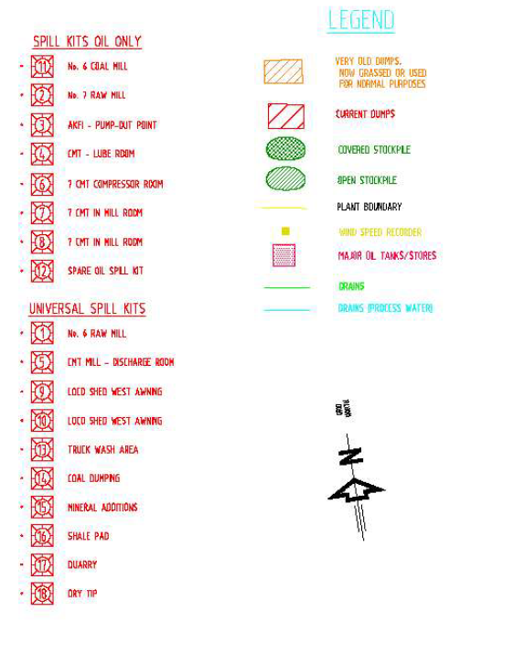
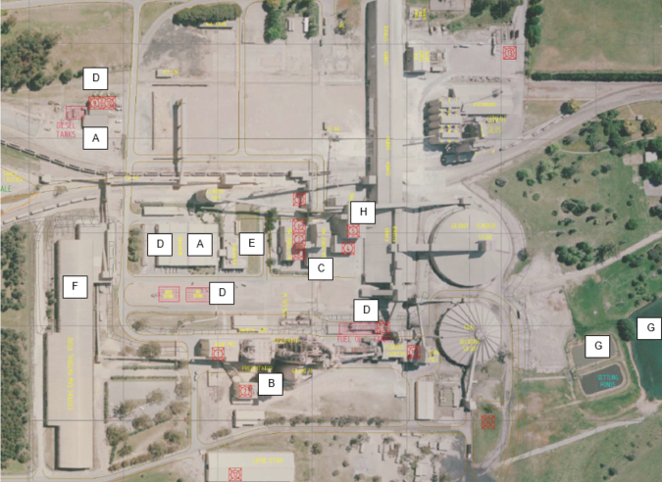
Figure 3 Map References of Polluting Substance Storage

Table 3 Polluting Substances Locations
Product/  Chemical Name | Maximum Quantity Stored | Location where the Product is Stored/Used | Storage Type | Is the Chemical a Dangerous Good? (Y/N) | Is the Chemical a Hazardous Substance? (Y/N)
Kiln Fuel – Diesel | 55000L | Tank No. SS60 | Tank | N | Y
Kiln Fuel – Diesel | 55000L | Tank No. SS61 | Tank | N | Y
Diesel | 60000L | AKF1 - SS63 | Tank | N | Y
Diesel | 22000L | AKF1 - SS64 | Tank | N | Y
Diesel Fuel | 25000L | Tank No. SS70 | Tank | N | Y
Diesel Fuel | 25000L | Tank No. SS71 | Tank | N | Y
LPG | 2500L | Depot 2 | Tank | Y | Y
LPG | 4500KG | Depot 2 | Tank | Y | Y
Acetylene | 1000KG | Gas Store | Bottles | Y | Y
Oxygen | 2500KG | Gas Store | Bottles | Y | Y
Hydrogen | 250KG | Gas Store | Gas bottles | Y | Y
LPG | 330KG | Gas Store | Gas bottles | Y | Y
Hydrochloric Acid (30%) | 30L | Laboratory | Bottles | Y | Y
Ethanol | 100L | Laboratory | Bottles | Y | Y
Methanol | 100L | Laboratory | Bottles | Y | Y
Kerosene | 10L | Laboratory | Bottles | Y | Y
Acetone | 20L | Laboratory | Bottles | Y | Y
Grinding Aid | 5000L | Cement Mill 6 | Tank | N | Y
Grinding Aid | 5000L | Cement Mill 7 | Tank | N | Y
Hydrochloric Acid (30%) | 1000L | Powerhouse pond | Tank | Y | Y
Hydrochloric Acid (30%) | 1000L | Hotwells | Tank | Y | Y
CALTEX DELO 400 SAE 15W/40 | 410L | Loco Shed | Drum | N | N
CALTEX RANDO HD 68 | 410L | Loco Shed | Drum | N | N
CALTEX 85W-140 Gear Oil | 205L | Loco Shed | Drum | N | N
CALTEX 80W-90 Gear Oil | 205L | Loco Shed | Drum | N | Y
Caltex Safe Degrease | 205L | Loco Shed | Drum | Y | Y
Waste Oil | 1000L | Loco Shed | ISO Container | Y | Y
CALTEX DELO 50/50 Coolant | 205L | Loco Shed | Drum | N | Y
Hydrogen | 156KG | Preheater L6 | Bottles | Y | Y
CALTEX DELO GREASE EP 2 | 40KG | OIL STORE | Drum | N | N
CALTEX EP GREASE C 3 | 40KG | OIL STORE | Drum | N | N
CALTEX MINE GREASE PREMIUM 2 | 180KG | OIL STORE | Drum | N | N
CALTEX RANDO HD 32 | 205L | OIL STORE | Drum | N | N
CALTEX TEXTRAN TDH PREMIUM | 205L | OIL STORE | Drum | N | N
CALTEX MEROPA 320 | 205L | OIL STORE | Drum | N | N
CALTEX TRANSFORMER OIL BSI INHBITED | 205L | OIL STORE | Drum | N | N
CALTEX DELO 400 SAE 15W/40 | 205L | OIL STORE | Drum | N | N
CALTEX TORQUE FLUID 434 | 205L | OIL STORE | Drum | N | N
CALTEX MEROPA 460 | 205L | OIL STORE | Drum | N | N
CALTEX RANDO HD 32 | 205L | OIL STORE | Drum | N | N
CALTEX RANDO HD 68 | 205L | OIL STORE | Drum | N | N
CALTEX RANDO HD 150 | 205L | OIL STORE | Drum | N | N
CALTEX MEROPA 320 | 205L | OIL STORE | Drum | N | N
CALTEX MEROPA SYNTHETIC EP 320 | 205L | OIL STORE | Drum | N | N
CALTEX TEXAMATIC 1888 | 205 | OIL STORE | Drum | N | N
CALTEX SAFE-D-GREASE QB | 205L | OIL STORE | Drum | N | Y
CALTEX KEROSENE | 200L | OIL STORE | Drum | Y | Y
CALTEX HAVOLINE FULLY SYNTHETIC 5W/40 | 205L | OIL STORE | Drum | N | N
Transformer Oils – Refer to Transformer Register | 765 to 7400L | Various | Transformers | Various | Various

Staff Roles and Responsibilities
Table 4 Staff Roles and Responsibilities
Position | Responsibility
Employees and Contractors | Following the procedures outlined in the PIRMP and related documents  Immediately alerting Supervisor or Team Leader of any environmental incidents or near-misses.
Team Leaders / Front Line Supervisors | Following the procedures outlined in the PIRMP and related documents  Immediately alerting Site/Production Manager or, in case of their unavailability, Environmental Representative or Environment Manager of any potentially material environmental incidents or near-misses.  Conducting incident investigations.
Site / Operations Manager  and/or  Site Environmental Business Partner  and/or  Environment Manager | Authorisation of the PIRMP  Administration, maintenance and implementation of the PIRMP  Assessing whether the incident has caused or threatens “material environmental harm” and, if so, immediately notifying all Appropriate Regulatory Authorities.  Ensuring that investigations are undertaken to a level corresponding to the level of risk and impact.

Internal Pollution Incident Reporting
Any pollution incident satisfying the material harm threshold must be immediately reported to relevant statutory authorities by either the Site/Operations Manager, or Environment Manager.
In cases where material harm level cannot be immediately assessed or insufficient information comes to hand on the severity of the incident, the general advice is to err on the side of caution and notify the Relevant Authorities with a qualification that the situation could not yet be fully assessed.
Until further notice the following procedure needs to be followed:
1. When a pollution incident occurs, a person who has become aware of it must immediately bring it to the attention of his/her immediate Supervisor or Manager
2. If necessary, first ring 000 for Emergency Services
3. At least one of the following Boral Cement personnel in Table 5 must be contacted immediately:
Table 5 Boral Cement Personnel
Name | Function | Phone Number | Mobile Number
Dean Beltrame | Operations Manager | 02 6365 5155 | 0401 895 743
Gabriel Paicu | Technical Manger | 02 6365 5155 | 0401 897 714
Branko Vulenta | Production Manager | 02 6365 5155 | 0401 892 097
Greg Johnson | Environment Manager – NSW/ACT | N/A | 0401 895 827
Ben Williams | Environment Business Partner – NSW/ACT | N/A | 0401 895 478
Whilst personal contact details are available in the controlled version of the Pollution Incident Response Management Plan located onsite they do not appear in the public document

4. Greg Johnson, or in case of his unavailability one of the Senior Management personnel listed above, is to immediately notify all appropriate Regulatory Authorities specified in Section 8.1.
5. In borderline situations, where the exceedance of the trigger level of “material harm” of a pollution incident may not be clear, a quick assessment including consultation with Boral environmental personnel should be undertaken to help the decision whether to notify or not.
6. Boral’s Senior Management must be informed promptly of the fact of immediate notification to the Authorities. This includes environmental personnel listed above, as well as Scott Carter, Girish Yadwad, Kate Woodbridge and Amy Jackson.

External Pollution Incident Reporting
As the legislation requires that notification must be done immediately upon becoming aware of the pollution incident, it is unlikely that a detailed picture will be available for reporting. Notwithstanding, is seems that some of the Government Authorities prepared a detailed questionnaire which is being filled at the time of this initial notification. Under the stress of incident handling it could be easy to provide a hasty, inaccurate estimate of the situation when answering these questions.
Therefore, the notification should be restricted to the facts known and nothing should be assumed or guessed. The details will be provided to the asking Authority later when more information comes to hand.
The initial notification should include as much of the following information (if known) as possible:
- Location and time of the pollution incident
- Type of the incident (spill, fire, unlicensed harmful discharge, etc)
- Assessed level of incident gravity: “it seems to be…” (e.g. “a relatively minor spill”; “major fire”, “explosion limited to one building”, etc.)
- Whether the Emergency Services have been required to attend.
Unless known for a fact, the answers to other questions should be politely deferred until a better assessment of the situation can be made.
The Boral person who is responsible for notifying the Authorities (Site/Operations Manager or Environment Manager) about the incident must prepare a Notification Log (a suitable form is attached in Part B) with the details of time of notifications and the persons who took to the call. The Authorities are expected to log the calls but early indications are that this is not always the case.
Notification of all Appropriate Government Authorities (at least 5 entities listed in Table 6) may take considerable time. Delays may be experienced connecting to the right person or no contact may be possible after hours. All such instances should be recorded in the Notification Log.

Pollution Incident Authority Contact List
The 5 entities which must be contacted in the case of emergency is detailed below in Table 6.
Table 6 Pollution Incident Authority Contact List
Government Authority – compulsory notifications | Emergency notification phone number
EPA – Environment Line | 131 555
Fire & Rescue NSW (FRNSW) | 1300 729 579
Wingecarribee Council | (02) 4868 0888
Public Health Unit (Southern Sydney) – Liverpool GW PHU | HealthLink (24 hr)- 1300 066 055  Head Office- Liverpool- (02) 9794 0855
WorkCover Authority of NSW | 131050  Company ABN asked: 62 008 528 523
Government Authority – ring if relevant | Emergency notification phone number
Police & Ambulance | 000
Roads and Maritime Services (road spills) | 132 701
NSW Office of Water | 02 8838 7885
Bush Fire Control Officer | 02 4677 7000
Poisons Information Centre | 131 126
Endeavour Energy (power line emergencies) | 131 003
Australian Radiation Protection and Nuclear Safety Agency | 1800 022 333

Community Notification Contact List
Communication with the local community may also be undertaken depending on the circumstances of the pollution incident. Berrima Cement would consider the following options for providing Early Warning and ongoing information to the community on pollution incidents:
- Direct phone contact with any local residents directly impacted by the pollution incident
- Letter Box drops of incident information and site contacts to local residents impacted by the pollution incident
- The inclusion of incident details within the relevant Community Newsletter and Community Meetings
The Stakeholder Relations Manager may be used to assist in the process of communicating with the community. Relevant community members in the immediate vicinity of the site are detailed below in Table 7.
Table 7 Community Notification Contact List
Name | Address | Postal Address | Preferred Contact | Email
New Berrima Residents
Grace Lawrence | 14 Brisbane Street, New Berrima |  | 02 4877 2441 | grace.gwen@bigpond.com
Neil Middleton | 5 Sydney Street, New Berrima |  | 4877 1561 | N/A
Rebecca & Nathaniel Mitchell | New Berrima |  | 0412 343 519 | nmi42680@bigpond.net.au
Tracey & Morgan O’Neil | 17 Sydney Street, New Berrima |  | 0409 771 183 | roxyroopoodle@hotmail.com
Trevor & Janice Gill | 30 Sydney Street, New Berrima |  | 4877 1094 | bygill@yahoo.com.au
Ken and Nao Mori | 3 Sydney Street, New Berrima |  | 4877 2858 | naomori77@yahoo.com.au
Mandy & Michael Eccleston | 22 Argyle Street, New Berrima |  | 4877 1174 | mandy@ecclestonbooks.com.au
Innes Hawk | 8 Howard Street, New Berrima |  | 4877 1321 | N/A
Christopher and Renata Kaegi | 43 Argyle Street, New Berrima |  | 0433 502 011 | Renata.kaegi@bigpond.com;  vwlion@bigpond.com
Steve Coupe & Sue Wallace | 12 Brisbane Street, New Berrima |  | 4877 2794  Mobile for Sue: 0438 218 217 | spuppet@ozemail.com.au
Dr Michael & Mrs Jane Cotter | New Berrima |  | 4877 1717  M: 0412 881 618 & 0412 158 267 | Janecotter2951@gmail.com;  michaelcotter@gmail.com
Steve Harris | 27 Brisbane Street, New Berrima |  | 4877 1809 or  0427 550 152 | N/A
Bryan Benson | 5 Howard Street, New Berrima |  | 4877 1998 | N/A
Dragica Haylock | Adelaide St, New Berrima |  | 4877119 | N/A
Neal Arnull | 88 Taylor Avenue, New Berrima |  | 4877 1449 | narnull@bigpond.net.au
Others
Tim Frost (Coordinator SHCAG) | 299 Oldbury Rd, Sutton Forest NSW 2577 |  | 0438 071 557 | fimf@magtech.com.au
Note: when alerting Tim Frost, please remember that he has a list of 4000 names of SHCAG members. He is eager to help notifying on our behalf, just make sure he notifies only people in the areas under threat from the pollution incident. This will have to be discussed with Tim in detail.

Register last updated 16/10/2012
Whilst personal contact details are available in the controlled version of the Pollution Incident Response Management Plan located onsite they do not appear in the public document

Incident Response Training
Berrima Cement will implement the Pollution Incident Response Management Plan by training or providing information to relevant employees and contractors in relevant areas of the Plan. The nature and objectives of staff training is to relate to site personnel the importance of early notification of any incidents and spills to site supervisors and key personnel.
Training or information will be provided on the following:
- The contents and intent of this PIRMP,
- The roles and responsibilities of site staff in relation to this PIRMP
- Spill response procedures;
- General environmental awareness; and / or
- Hazardous materials awareness.
Site inductions for visitors and sub-contractors also advise individuals to report any environmental incidents or spills to site supervisors and key personnel immediately. Key site personnel and supervisors participate in PIRMP Drills which are used as practical training and can also be used to identify any potential gaps or areas for improvement for the PIRMP. A summary of the PIRMP Drills undertaken is shown below in Table 8.
Table 8 Summary of PIRMP Drills
Test Date | Version of PIRMP tested | Incident Drilled
08/04/2022 | 10 | Loss of Radioactive Material
28/04/2021 | 9 | New Incident: Gas Escape
07/04/2020 | 8 | Incident 4: Escape of hydrocarbon into Lake Quality
06/05/2018 | 7 | Incident 4: Escape of hydrocarbon into Lake Quality
26/04/2018 | 6 | Incident 2: Loss of fuel due to refueling from diesel tank
30/03/2017 | 5 | Incident 7: Mobile Plant, hydraulic hose or tank failure

Please note that V10 of the PIRMP consolidated the incident list. Incident numbers may be reflective of old versions of the PIRMP.
A sign-off sheet is kept of the personnel present for the undertaking of a PIRMP Drill and a record is kept on when and how the PIRMP is communicated to employees. This information forms a section of the PIRMP Drill document.

PIRMP Testing
Plans must be tested routinely at least once every 12 months. The testing is to be carried out in such a manner as to ensure that the information included in the plan is accurate and up to date, and that each plan is capable of being implemented in a workable and effective manner.
Routine testing of the PIRMP will be conducted annually, and can be completed through the following methods:
- Simulated environmental emergency drills/exercises, or
- Desktop simulations.

PIRMP Review
Revisions are to be coordinated by the Site Manager and Environmental Representative. The objectives of a review are:
- To maintain compliance with the statutory requirements,
- To identify opportunities for improvement in the Plan, and reduce the risk to human health and the environment, and
- To identify any changes in personnel or regulatory contact information.

Event Based
Events which may trigger a review of this Plan or its associated documents include:
- Within 1 month of reporting to the nominated parties in accordance with the plan, after a pollution incident, or
- Modification/Improvement to the system

Time Based
Berrima Cement will review this management plan routinely every 12 months. The Plan review will include:
- This Document, and
- Legislation, Approval and Licence changes.
- Any internal personnel changes

Risk Assessment of Potential Incidents
A risk assessment of each potential incident has been undertaken and is detailed in Table 9.

Table 9 Risk Assessment and Corrective Control Measures of Incidents
Hazard and Likelihood Risk Assessment and Corrective Control Measures
Site:  Berrima Cement Works |  |  |  |  |  |  | Responsible Person:  Operations Manager |  | Review Date:  08 April 2022
Name / ref of pollutant /  chemicals | Description of Hazard / Incident leading to hazard | C | L | R | Impact on Neighbours | Factors which could increase risk |  | Residual Risk after implementation of controls. (See Table 1 for list of current controls). |  | Responsible person | Action date
Diesel / Hydrocarbon  Spill | Incident #1  Uncontrolled loss of Diesel or other hydrocarbon products that could result in material harm to the environment or human health | 2 | 2 | L4 | N | Dry, windy conditions (increase fire danger) or heavy rain/flood conditions (will increase potential for spill to spread to catchment drainage areas) |  | Consequence: (Minor 2): Failure resulting in loss of all or substantial volume of tanks would be captured entirely by existing primary bund with no release to soil or water.  Likelihood: (Unlikely 2): Diesel Tanks are self bunded double walled fuel tanks. Due to location of tank, damage to tanks is unlikely to occur from external equipment. In addition tanks are maintained in good structural integrity with low risk of failure through corrosion. Drain valve, hoses and refuelling equipment are maintained in good structural integrity with low risk of failure The drain valve is locked at all times.  Risk Assessment = Minor 2 Vs Unlikely 2 = L4 |  | As per PIRMP action plan | When required
Airborne dust | Incident #2  Excessive airborne dust from stockpiled material, mobile plant or traffic areas causing material harm to the environment or significant impact to community | 2 | 2 | L4 | Y (Neighbours notified will be dependent on wind direction) | Dry, windy conditions (increase wind erosion and dust transport). Summer months with long periods of extended dry conditions. |  | Consequence: (Minor 2): Excessive dust from stockpile during high winds causing nuisance to surrounding area.  Likelihood: (Unlikely 2): Stockpiles are maintained to a manageable level on a monthly basis. Use of water sprinklers and water cart onsite during windy periods. Extensive land reserves act as buffer land from surrounding communities. Surrounding land is rural with sparse distribution of neighbours.  Risk Assessment = Minor 2 Vs Unlikely 2 = L4 |  | As per PIRMP action plan | When required
Sediment laden stormwater | Incident #3  Uncontrolled release of sediment laden water from storage dams causing material harm to the environment | 2 | 2 | L4 | Y  (Neighbours to be notified will be downstream of Lake Quality and Stony Creek) | Extended periods of rain increase the risk. Late Summer/early Autumn is typically the wettest part of the year on site. |  | Consequence: (Minor 2): Failure of one or more sediment dams are likely to result in off-site impacts to water courses which would predominantly reduce water quality over a short period of time. As such, impact to the environment/human health is not considered to be significant.  Likelihood: (Unlikely 2): Dams are frequently monitored and inspected for levels and integrity.  Risk Assessment = Minor 2 Vs Unlikely 2 =L4  Note: For PIRMP purposes overflow events during extreme wet weather will be reported under POEO Licence obligations and not Immediate Reporting. |  | As per PIRMP action plan | When required
Electrostatic Precipator Trip | Incident #4  Electrostatic Precipator Trip | 2 | 2 | L4 | N | Dry, windy conditions increase transport potential. Wind from south is in direction of nearby residents). Summer months with long periods of extended dry conditions will increase ignition risk of flammable gases and consequence. |  | Consequence: (Minor 2): Localised impact regulatory consequence managed with 24hr limits  Likelihood: (Unlikely 2): Electrostatic Precipitator Trip is unlikely due to regular maintenance and calibration, on most occasion the system resets with no issue  Risk Assessment = Minor 2 Vs Unlikely 2 =L4 |  | As per PIRMP action plan | When required
Gas Escape | Incident #5 | 4 | 2 | H8 | Y  (Neighbours notified will be dependent on wind direction) | Dry, windy conditions increase transport potential. Wind from south is in direction of nearby residents). Summer months with long periods of extended dry conditions will increase ignition risk and consequence. |  | Consequence: (Major 4) Potential for explosion and residential areas of New Berrima to be evacuated.  Likelihood: (Unlikely 2): Maintenance and inspections make it very unlikely that a gas leak will occur  Risk Assessment = Major 4 Vs Unlikely 2 =H8 |  | As per PIRMP action plan | When required
Loss of radioactive material | Incident #6 | 4 | 1 | M4 | Y | Extreme weather events would increase the risk of failure during transport or maintenance. |  | Consequence: (Major 4) Potential for exposure and impacted areas of New Berrima to be evacuated and isolated.  Likelihood: (Rare 1): Maintenance and inspections.  Risk Assessment = Major 4 Vs Unlikely 2 =H8

Part B:
Incident Response Actions
and
Notification Logs

Incident 1: Diesel or Hydrocarbon Spill
Table 10 Diesel/hydrocarbon Spill Response Actions
Incident 1 | Uncontrolled loss of diesel or other hydrocarbon products that could result in material harm to the environment or human health. See Figure 4, 5 and 6  Actions Required:  - Contact all relevant people/department (refer to Immediate Reporting Contact Sheet in Table 16  - Ensure bund/liner are capturing full volume of diesel  - Ensure bund integrity is sound throughout the entire period of incident (i.e. periodic inspections)  - Contact service provider (Cleanaway 13 13 39) to pump-out bund contents.  - Area to be restricted to Incident Response Personnel  - Ensure spill kit available for any release from bund/liner  - If any release from bund/liner onto unsealed soil/surface water - Environmental Consultants to be engaged to investigate and remediate contamination.  - Repair/replace tanks  - Inspect bund for ongoing serviceability
Alarm raising | Any personnel involved or witnessing incident to report to immediate supervisor and PIRMP actions to be implemented.
Emergency Controller | - Emergency Controller: Operations Manager or delegate  - Call service provider: Operations Manager or delegate  - Spill Kit manager: Onsite supervisor or delegate  - Periodic inspections and update reporting of site and bund: Onsite supervisor or delegate
Scale of incident | Incident would be restricted to the bunded diesel storage area with minimal external impact, however, potential for bund/liner overflow or failure may result in soil and surface water contamination that will require specialist investigation/remediation.
Evacuate | Only if fire or explosion potential exists. Operations Manager to begin evacuation if advice provided by Fire Department to do so as part of immediate notification.
Communications | Internal:  - Operations Manager or delegate to use contact sheet for all internal (Boral) contacts. See Table 16 for the list of internal details  External mandatory:  - Immediate Reporting Contact Sheet to be See Table 16 for the list of authorities to be contact and fill in the immediate notification log in Table 15  External non-mandatory:  - Consider contact neighbours only if diesel has escaped into storm-water drainage lines and will enter Stony Creek and affect residents shown in Figure 6. See Table 17 for the community notification list and contact relevant people.  Further guidance on communication can be found in Part A Section 7 and 8
Rescuer / respondent + safety checks | As per Site Emergency Plan CEM-BER-OHS-01 or Fire Department as part of Immediate Reporting
Rescue + First Aid | As per Site Emergency Plan CEM-BER-OHS-01 or Fire Department as part of Immediate Reporting
Clean up and  Waste disposal | Service Provider to dispose of diesel and advise on required clean-up. Environmental consultants to be engaged to investigate and remediate contamination.
Reporting and re-preparedness | See HSEQ MS:  - Incident Reporting, Investigation and Action Management Standard (GRP-HSEQ 3-02)

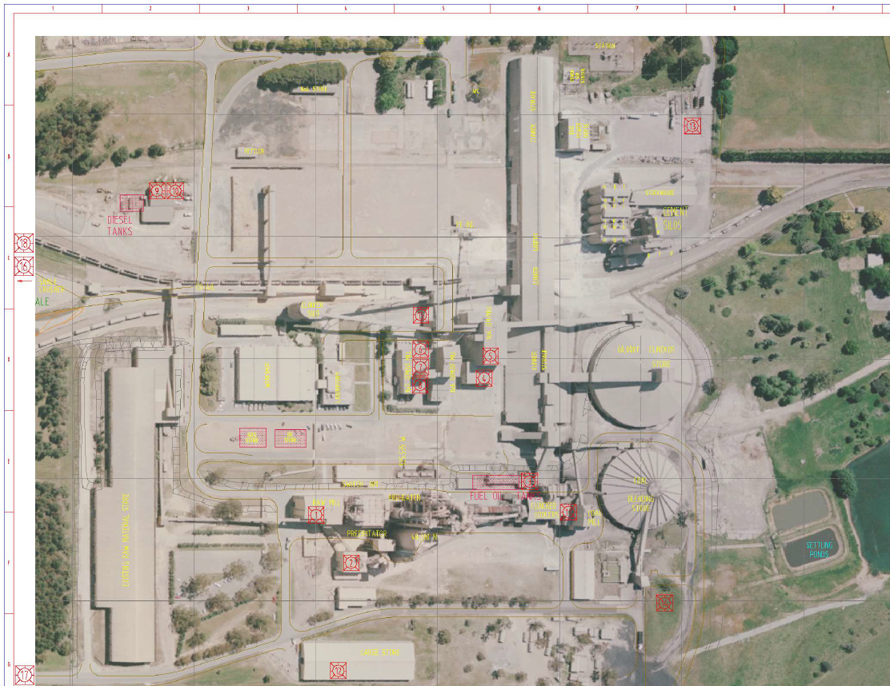
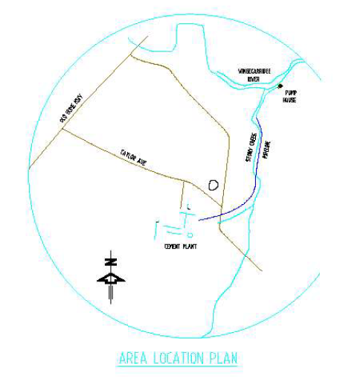

Figure 4 Locations of Fuel Storage and Spill Kits

Note that diesel fueling facilities are located at the designated storage areas and tanks within the site. Mobile Plant tank failure would depend on the location of the break down to the site. All mobile plant are fitted with fire extinguishers.
The water drainage is shown below in Figure 5 and Figure 6 can assist in determining whether or not the spill has entered site drainage and has the potential to be transported off-site.
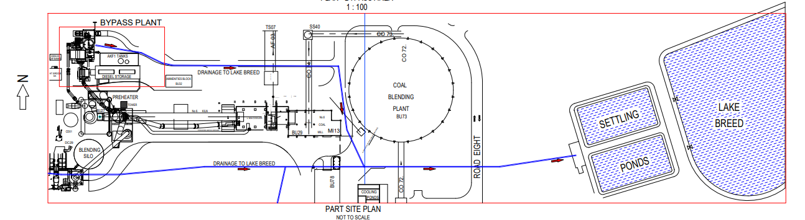
Figure 5 Location of Site Drainage
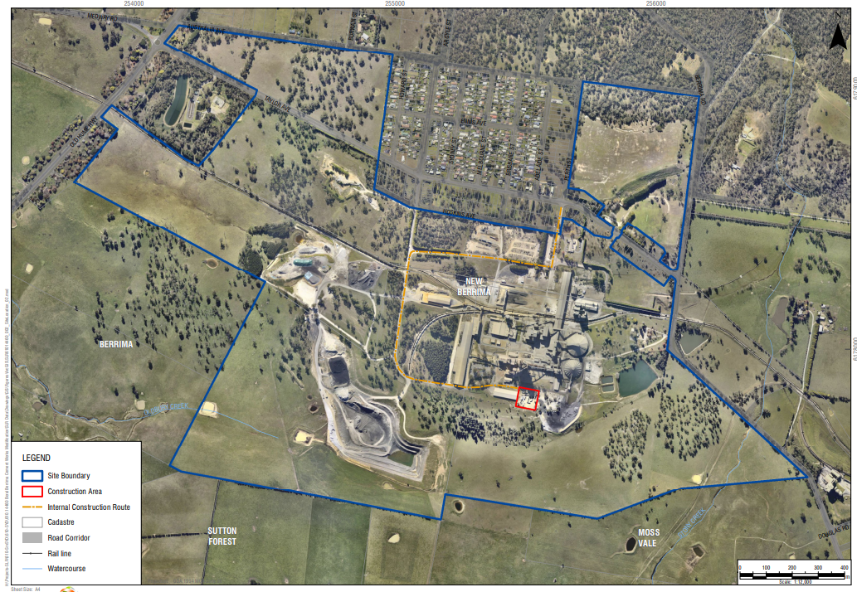
Figure 6 Potentially Affected Residents Incident 1

Incident 2: Excessive Airborne Dust
Table 11 Excessive Airborne Dust Response Actions
Incident 2 | Excessive airborne dust from stockpiled material, mobile plant or traffic areas causing material harm to the environment or significant impact to community. See Figure 7 and 8.  Actions Required:  - Employees, Contractor/Visitor to notify site representative of issue immediately.  - Dust suppression activity to commence immediately on stockpiles via water cart or other means.  - Any operations associated with disturbing the stockpiles, such as driving and dumping on, to be minimised or ceased.  - Daily monitoring to be undertaken to assess weather and site conditions. Utilise real time dust monitoring and weather station monitoring as required  - Contact all relevant people/department (refer to Immediate Reporting Contact Sheet in Table 16)
Alarm raising | Any personnel involved or witnessing incident to report to immediate supervisor and PIRMP actions to be implemented.
Emergency Controller | - Emergency Controller: Quarry Manager or delegate  - Call service provider: Quarry Manager or delegate  - Periodic inspections and update reporting of site and stockpiles: Onsite supervisor or delegate
Scale of incident | Incident would be localised to the area surrounding stockpile area, with minimal external offsite impact.
Evacuate | Only if fire or explosion potential exists. Quarry Manager and any advice provided by Fire Department as part of attendance after immediate notification.
Communications | Internal:  - Operations Manager or delegate to use contact sheet for all internal (Boral) contacts. See Table 16 for the list of internal details  External mandatory:  - Immediate Reporting Contact Sheet to be See Table 16 for the list of authorities to be contact and fill in the immediate notification log in Table 15  External non-mandatory:  - Consider contact neighbours only if dust significantly impacting residences. Potentially impacted residents would be dependent on wind conditions in Figure 8. See Table 17 for the community notification list and contact relevant people.  Further guidance on communication can be found in Part A Section 7 and 8
Rescuer / respondent + safety checks | As per Site Emergency Plan or Fire Department as part of Immediate Reporting
Rescue + First Aid | As per Site Emergency Plan or Fire Department as part of Immediate Reporting
Clean up and  Waste disposal | All water carts to be placed on areas producing airborne dust. If necessary work must be ceased to control airborne dust. No disposal of waste required.
Reporting and re-preparedness | See HSEQ MS:  Incident Reporting, Investigation and Action Management Standard (GRP-HSEQ 3-02)

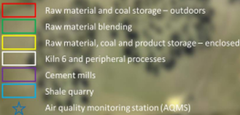
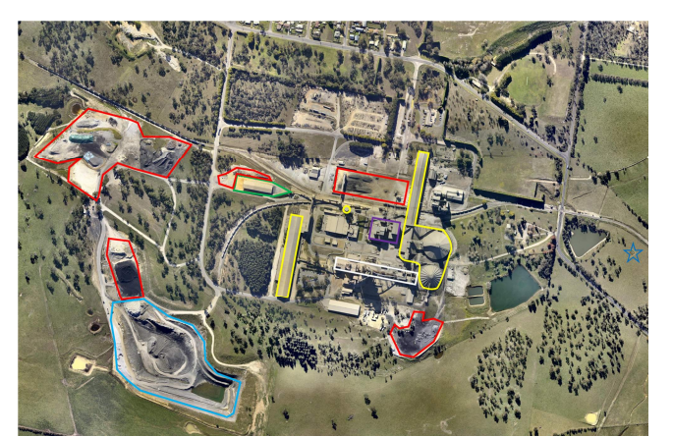
Figure 7 Potential Sources of Dust
Please note that pollution controls include operational response which is not included on these maps. See Part A Section 12 for more detail on pollution controls for Incident 2
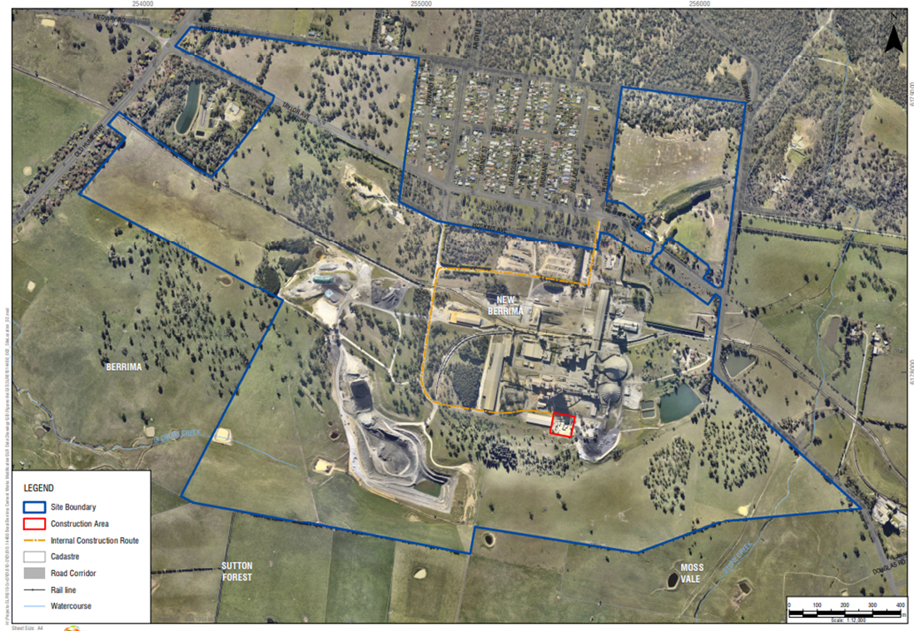
Figure 8 Potentially Affected Residents Incident 2

Incident 3: Dam Failure
Incident 3 | Uncontrolled release of sediment laden water from storage dams failure causing material harm to the environment. See Figure 9 and 10  Actions Required:  - Contact all relevant people/department (refer to Immediate Reporting Contact Sheet)  - Ensure bund integrity is sound throughout the entire period of incident (i.e. periodic inspections)  - Contact local neighbours if going to be in inundated by rise of water  - Area to be restricted to Incident Response Personnel  - If any release from site onto unsealed soil/surface water - Environmental Consultants to be engaged to investigate and remediate contamination, if any  - Contact local contractor to rebuild dams immediately
Alarm raising | Any personnel involved or witnessing incident to report to immediate supervisor and PIRMP actions to be implemented.
Emergency Controller | - Emergency Controller: Operations Manager or delegate  - Call service provider: Operations Manager or delegate  - Spill Kit manager: Onsite supervisor or delegate  - Periodic inspections and update reporting of site and bund: Onsite supervisor or delegate
Scale of incident | Catastrophic failure of one or more sediment dams are likely to result in off-site impacts to water courses which would predominantly reduce water quality over a short period of time. As such, impact to the environment/human health is not considered to be significant.
Evacuate | Only if flood potential exists. Quarry Manager and any advice provided by Fire Department as part of attendance after immediate notification.
Communications | Internal:  - Operations Manager or delegate to use contact sheet for all internal (Boral) contacts. See Table 16 for the list of internal details  External mandatory:  - Immediate Reporting Contact Sheet to be See Table 16 for the list of authorities to be contact and fill in the immediate notification log in Table 15  External non-mandatory:  - Consider contact neighbours only residents will be inundated with sediment laden water at locations shown in Figure 10. See Table 17 for the community notification list and contact relevant people.  Further guidance on communication can be found in Part A Section 7 and 8
Rescuer / respondent + safety checks | As per Site Emergency Plan or Fire Department as part of Immediate Reporting
Rescue + First Aid | As per Site Emergency Plan or Fire Department as part of Immediate Reporting
Clean up and  Waste disposal | Depending on severity of incident, consultants to be contacted to advise on required clean-up.
Reporting and re-preparedness | See HSEQ MS:  - Incident Reporting, Investigation and Action Management Standard (GRP-HSEQ 3-02)

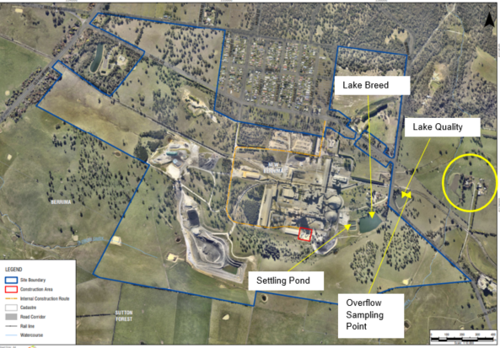
Figure 9 Location of Storage Dams and Potentially Affected Residents
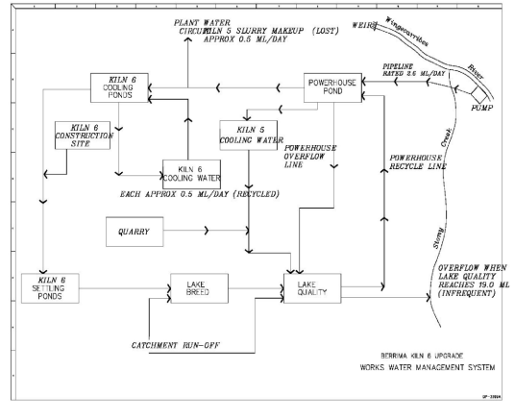
Figure 10 Overview of Site Water Management System
Please note that pollution controls include inspections and operational response which are not showed on these maps. See Section 12 for more details. For PIRMP purposes overflow events during extreme wet weather will be reported under POEO Licence obligations and not immediate reporting.

Incident 4: Electrostatic Precipitator Trip
Table 12 Electrostatic Precipitator Trip Response Actions
Incident 4 | Electrostatic Precipitator Trip. See Figure 11 and 12  Actions Required:  - Control Room to notify Technical Manager  - Monitor real time information to assess if 24 limit will be exceeded  - Consider shut down based on information if reset occurs Gabriel to Confirm if procedure available  - Contact all relevant people/department (refer to Immediate Reporting Contact Sheet)  - Contact maintenance team for assessment  - If any release from stacks will affect near neighbors site PIRMP is to be followed  - Call service provider to inspect real time monitor & equipment for serviceability if required
Alarm raising | Site Management to contact environment manager to assess the need for regulatory notification, and PIRMP actions to be implemented.
Emergency Controller | - Control room Supervisor  - Notify Technical Manager  - Notify Site Operations Manager  - Track 24hr emissions graph and wind direction
Scale of incident | Incident would be likely be localised to the area with no external impact, potential for incident on a large scale with external impact is unlikely but possible.
Evacuate | Only if emissions impact exists. Site Manager and any advice by safety team will determine necessity.
Communications | Internal:  - Operations Manager or delegate to use contact sheet for all internal (Boral) contacts. See Table 16 for the list of internal details  External mandatory:  - Immediate Reporting Contact Sheet to be See Table 16 for the list of authorities to be contact and fill in the immediate notification log in Table 15  External non-mandatory:  - Consider contact neighbours if emissions significantly impacting residences. Potentially impacted residents would be dependent on wind conditions. See Table 17 for the community notification list and contact relevant people.  Further guidance on communication can be found in Part A Section 7 and 8
Rescuer / respondent + safety checks | As per Site Emergency Plan and PIRMP
Rescue + First Aid | As per Site Emergency Plan or Fire Department as PIRMP Reporting
Clean up and  Waste disposal | N/A.
Reporting and re-preparedness | Incident Notification SOP (GRP-HSEQ-3-02 Incident Reporting Investigation and Action Management)

Location of precipitator
Figure 11 Location of the Precipitator
Figure 12 Potentially Affected Residents Incident 4

Incident 5: Gas Leak
Table 13 Gas Leak Response Actions
Incident 5 | Failure leading to escape of flammable gas. See Figure 13 and 14  Actions Required:  - Control Room to notify Operations Manager  - Move people in immediate danger to safety  - If safe to do so, assist and care for injured personnel and call for first aid assistance  - Shut down or switch off equipment as required. LEAVE LIGHTS ON.  - Restrict the area  - Contact all relevant people/department (refer to Immediate Reporting Contact Sheet)  - Contact maintenance team for assessment  - Monitor real time information to assess if 24 extent of leak  - If any release from stacks will affect near neighbors site enact early warning procedures  - Monitor real time information to assess if 24 extent of leak  - Call service provider to inspect real time monitor & equipment for serviceability if required
Alarm raising | Any personnel involved or witnessing incident to report to immediate supervisor and PIRMP actions to be implemented.
Emergency Controller | Emergency Controller: Operations Manager or delegate  Call service provider: Operations Manager or delegate  Periodic inspections and update on maintenance: Onsite supervisor or delegate
Scale of incident | Catastrophic failure of gas storage are likely to result in off-site impacts to air quality and an increased fire risk. It is likely that early warning notifications would need to be provided to residents if evacuation is required. The fire department will advise on scale.
Evacuate | If advice provided by Fire Department as part of attendance after immediate notification.
Communications | Internal:  - Operations Manager or delegate to use contact sheet for all internal (Boral) contacts. See Table 16 for the list of internal details  External mandatory:  - Immediate Reporting Contact Sheet to be See Table 16 for the list of authorities to be contact and fill in the immediate notification log in Table 15  External non-mandatory:  - Consider contact neighbours if emissions significantly impacting residences. Potentially impacted residents would be dependent on wind conditions. See Table 17 for the community notification list and contact relevant people.  Further guidance on communication can be found in Part A Section 7 and 8
Rescuer / respondent + safety checks | As per Site Emergency Plan or Fire Department as part of Immediate Reporting
Rescue + First Aid | As per Site Emergency Plan or Fire Department as part of Immediate Reporting
Clean up and  Waste disposal | Depending on severity of incident, consultants to be contacted to advise on required clean-up.
Reporting and re-preparedness | See HSEQ MS:  Incident Reporting, Investigation and Action Management Standard (GRP-HSEQ 3-02)

Location of gas storage
Figure 13 Location of Gas Escape Incident
Figure 14 Potentially Affected Residents Incident 5

Incident 6: Loss of Radioactive Material
Table 14 Loss of Radioactive Material Response Actions
Incident 6 | Loss of radioactive material from equipment. See Figure 13 and 14  Actions Required:  - Immediately contact Operations Manager and Accredited Service Provider (Troy Jones (02) 42 68 6192 or 0409 669 491)  - Immediately remove all persons from the vicinity of the incident  - Area will be restricted to incident response personnel. Cordon off a perimeter of at least ten metres and monitor the radiation dose rates along all accessible sides of the perimeter. Extensions to the perimeter may be required if the dose rates levels exceed 10 μSv/hr  - If a plant fire occurs, the Radiation Safety Officer will ensure that the attending fire brigade is aware of the location of the radiation gauges  - Radiation Specialist will notify operations manager if source is lost or damaged, or if any employee has received a dose > 1mSv.  - Contact all relevant people/department (refer to Immediate Reporting Contact Sheet)  - Consult with radiation specialist for further remediation measures  - If the incident has within transit, transport of the gauge should be made directly to the manufacturer’s premises or other approved ‘Isotope Handling Facility’, so that the necessary repairs can be undertaken if so required.
Alarm raising | Any personnel involved or witnessing incident to report to immediate supervisor and PIRMP actions to be implemented.
Emergency Controller | Emergency Controller: Operations Manager or delegate  Call service provider: Operations Manager or delegate  Periodic inspections and update on maintenance: Onsite supervisor or delegate
Scale of incident | Catastrophic failure of gas storage are likely to result in off-site impacts to air quality and an increased fire risk. It is likely that early warning notifications would need to be provided to residents if evacuation is required. The fire department will advise on scale.
Evacuate | If advice provided by Service Provider or Fire Department as part of attendance after immediate notification.
Communications | Internal:  - Operations Manager or delegate to use contact sheet for all internal (Boral) contacts. See Table 16 for the list of internal details  External mandatory:  - Immediate Reporting Contact Sheet to be See Table 16 for the list of authorities to be contact and fill in the immediate notification log in Table 15  External non-mandatory:  - Consider contact neighbours if advised by service provider that an ignition risk or risk to human health exists if emissions significantly impacting residences. Potentially impacted residents would be dependent on wind conditions. See Table 17 for the community notification list and contact relevant people.  Further guidance on communication can be found in Part A Section 7 and 8.
Rescuer / respondent + safety checks | As per Site Emergency Plan or Fire Department as part of Immediate Reporting
Rescue + First Aid | As per Site Emergency Plan or Fire Department as part of Immediate Reporting
Clean up and  Waste disposal | Depending on severity of incident, consultants to be contacted to advise on required clean-up.
Reporting and re-preparedness | See HSEQ MS:  Incident Reporting, Investigation and Action Management Standard (GRP-HSEQ 3-02)
Radiation Gauges
Figure 15 Location of Fixed Radiation Gauges
Figure 16 Potentially Affected Residents Incident 6

Pollution Incident Notification Log
Person undertaking notification (Name/Function):
Date and time when first become aware of the incident:
Incident type:
Comments:

Table 15 Initial Immediate Notification Log
Appropriate Regulatory Authority | Time of call | Respondent’s name/function |  | Approximate call duration | Comments
EPA
Public Health Unit
Fire and Rescue NSW
Local Council
Safework NSW
Other: (including neighbours)
Other: (including neighbours)
Other: (including neighbours)
Other: (including neighbours)
Other:

Summary of initial communication:

Person undertaking notification (Name/Function):
Date and time when additional information become available:
Comments:

Immediate notification of further pertinent information (if applicable)
Appropriate Regulatory Authority | Time of call | Respondent’s name/function | Approximate call duration | Comments
EPA
Public Health Unit
Fire and Rescue NSW
Local Council
SafeWork NSW
Other:
Other:
Summary of additional communication

Immediate Notification Sheet
Table 16 Immediate Notification Sheet
INTERNAL NOTIFICATION SHEET
Name | Function |  | Phone Number | Mobile Number
Dean Beltrame | Operations Manager |  | 02 6365 5155 | 0401 895 743
Gabriel Paicu | Technical Manger |  | 02 6365 5155 | 0401 897 714
Branko Vulenta | Production Manager |  | 02 6365 5155 | 0401 892 097
Greg Johnson | Environment Manager – NSW/ACT |  |  | 0401 895 827
Ben Williams | Environment Business Partner – NSW/ACT |  |  | 0401 895 478
Government Authority – compulsory notifications |  | Emergency notification phone number
EPA – Environment Line |  | 131 555
Fire & Rescue NSW (FRNSW) |  | 1300 729 579
Wingecarribee Council |  | (02) 4868 0888
Public Health Unit (Southern Sydney) – Liverpool GW PHU |  | HealthLink (24 hr)- 1300 066 055  Head Office- Liverpool- (02) 9794 0855
SafeWork NSW |  | 131 050  Company ABN asked: 62 008 528 523
Government Authority – ring if relevant |  | Emergency notification phone number
Police & Ambulance |  | 000
Roads and Maritime Services (road spills) |  | 132 701
NSW Office of Water |  | 02 8838 7885
Bush Fire Control Officer |  | 02 4677 7000
Poisons Information Centre |  | 131 126
Endeavour Energy (power line emergencies) |  | 131 003
Australian Radiation Protection and Nuclear Safety Agency |  | 1800 022 333

Table 17 Community Notification Contact List
Name | Address | Postal Address | Preferred Contact | Email
New Berrima Residents - contact if relevant
Grace Lawrence | 14 Brisbane Street, New Berrima |  | 02 4877 2441 | grace.gwen@bigpond.com
Neil Middleton | 5 Sydney Street, New Berrima |  | 4877 1561
Rebecca & Nathaniel Mitchell | New Berrima |  | 0412 343 519 | nmi42680@bigpond.net.au
Tracey & Morgan O’Neil | 17 Sydney Street, New Berrima |  | 0409 771 183 | roxyroopoodle@hotmail.com
Trevor & Janice Gill | 30 Sydney Street, New Berrima |  | 4877 1094 | bygill@yahoo.com.au
Ken and Nao Mori | 3 Sydney Street, New Berrima |  | 4877 2858 | naomori77@yahoo.com.au
Mandy & Michael Eccleston | 22 Argyle Street, New Berrima |  | 4877 1174 | mandy@ecclestonbooks.com.au
Innes Hawk | 8 Howard Street, New Berrima |  | 4877 1321
Christopher and Renata Kaegi | 43 Argyle Street, New Berrima |  | 0433 502 011 | Renata.kaegi@bigpond.com;  vwlion@bigpond.com
Steve Coupe & Sue Wallace | 12 Brisbane Street, New Berrima |  | 4877 2794  Mobile for Sue: 0438 218 217 | spuppet@ozemail.com.au
Dr Michael & Mrs Jane Cotter | New Berrima |  | 4877 1717  M: 0412 881 618 & 0412 158 267 | Janecotter2951@gmail.com;  michaelcotter@gmail.com
Steve Harris | 27 Brisbane Street, New Berrima |  | 4877 1809 or  0427 550 152
Bryan Benson | 5 Howard Street, New Berrima |  | 4877 1998
Dragica Haylock | Adelaide St, New Berrima |  | 4877119
Neal Arnull | 88 Taylor Avenue, New Berrima |  | 4877 1449 | narnull@bigpond.net.au
Others – contact if relevant
Tim Frost (Coordinator SHCAG) | 299 Oldbury Rd, Sutton Forest NSW 2577 |  | 0438 071 557 | fimf@magtech.com.au
Note: when alerting Tim Frost, please remember that he has a list of 4000 names of SHCAG members. He is eager to help notifying on our behalf, just make sure he notifies only people in the areas under threat from the pollution incident. This will have to be discussed with Tim in detail.

Register last updated 16/10/2012
Guidance for notifying relevant neighbours is detailed in Part A Section 8.2

If the incident may impact on neighbours trigger the early warnings assessment and actions

